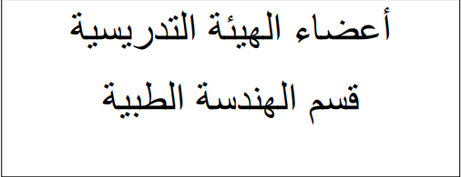

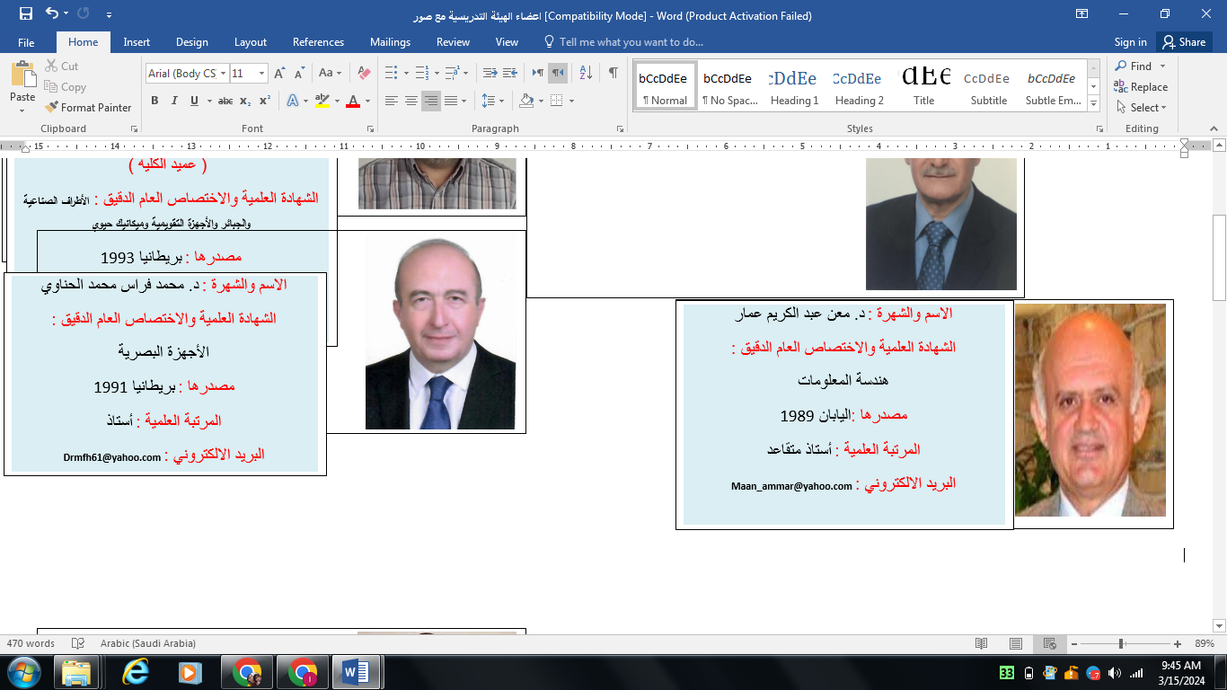

[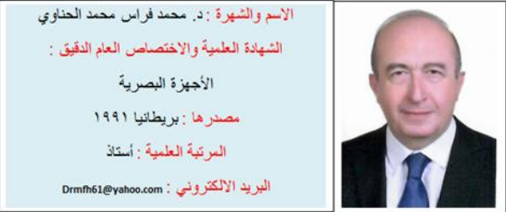](http://damascusuniversity.edu.sy/fmee/downloads/files/1668875974_%D8%A7%D9%84%D8%B3%D9%8A%D8%B1%D8%A9%20%D8%A7%D9%84%D8%B0%D8%A7%D8%AA%D9%8A%D8%A9-%D8%AF%20%D9%81%D8%B1%D8%A7%D8%B32022.pdf)

[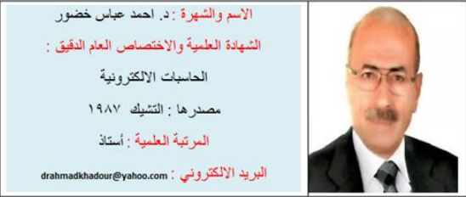](http://damascusuniversity.edu.sy/fmee/downloads/files/1670228534_%D8%AF.%D8%A7%D8%AD%D9%85%D8%AF.pdf)

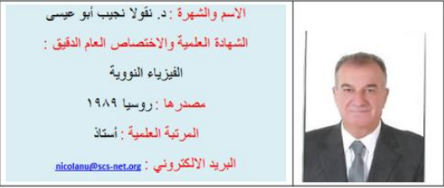

[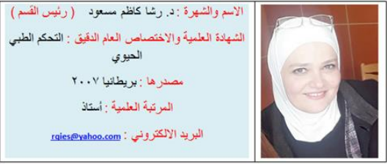](http://damascusuniversity.edu.sy/fmee/downloads/files/1668875759_%D8%A7%D9%84%D8%A3%D8%B3%D8%AA%D8%A7%D8%B0%D8%A9%20%D8%A7%D9%84%D8%AF%D9%83%D8%AA%D9%88%D8%B1%D8%A9%20%D8%B1%D8%B4%D8%A7%20%D9%85%D8%B3%D8%B9%D9%88%D8%AF_2022.pdf)

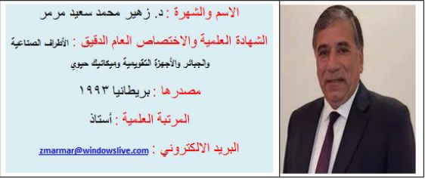

[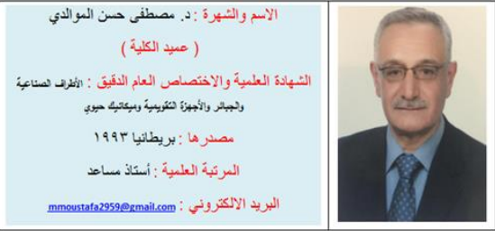](http://damascusuniversity.edu.sy/fmee/downloads/files/1668875861_%D8%A7%D9%84%D8%B3%D9%8A%D8%B1%D8%A9%20%D8%A7%D9%84%D8%B0%D8%A7%D8%AA%D9%8A%D8%A9%20%D8%AF%20%D9%85%D8%B5%D8%B7%D9%81%D9%89%20%D8%A7%D9%84%D9%85%D9%88%D8%A7%D9%84%D8%AF%D9%8A1.pdf)

[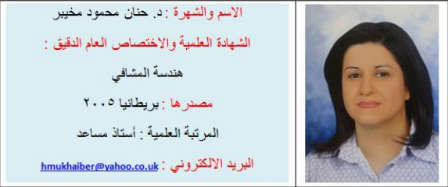](http://damascusuniversity.edu.sy/fmee/downloads/files/1668876502_%D8%A7%D9%84%D8%B3%D9%8A%D8%B1%D8%A9%20%D8%A7%D9%84%D8%B0%D8%A7%D8%AA%D9%8A%D8%A9%20%D8%AF.%20%D8%AD%D9%86%D8%A7%D9%86%20%D9%85%D8%AD%D9%85%D9%88%D8%AF%20%D9%85%D8%AE%D9%8A%D8%A8%D8%B1.pdf)

[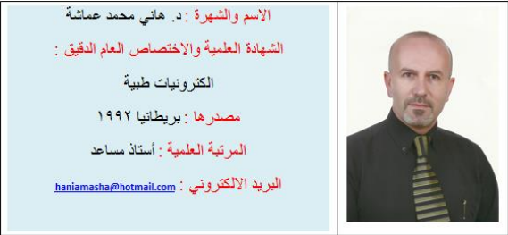](http://damascusuniversity.edu.sy/fmee/downloads/files/1669270365_Resume%20Dr%20Hani%20Amasha%20August%202021.pdf)

[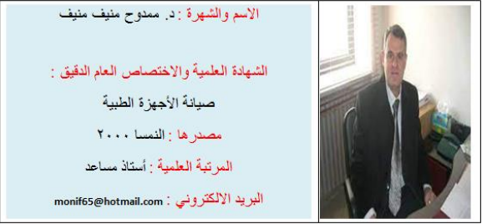](http://damascusuniversity.edu.sy/fmee/downloads/files/1668876817_%D8%AF.%20%D9%85%D9%85%D8%AF%D9%88%D8%AD%20%D9%85%D9%86%D9%8A%D9%81.pdf)

[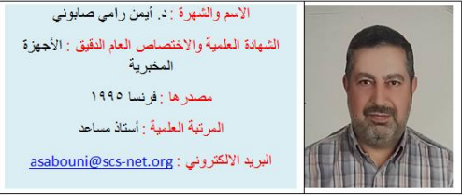](http://damascusuniversity.edu.sy/fmee/downloads/files/1669270404_Dr.Ayman%20Sabbouni.pdf)

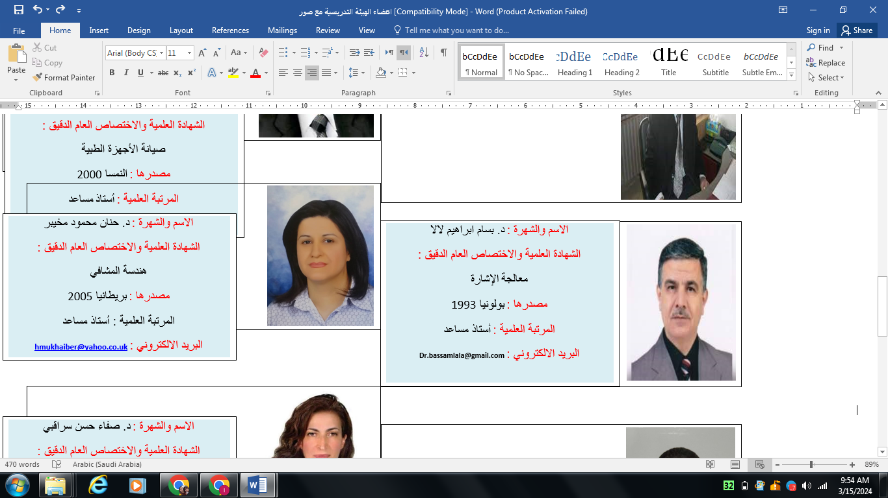

[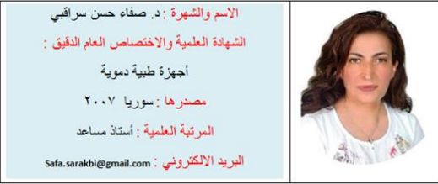](http://damascusuniversity.edu.sy/fmee/downloads/files/1668876564_%D8%AF.%20%D8%B5%D9%81%D8%A7%D8%A1%20%D8%B3%D8%B1%D8%A7%D9%82%D8%A8%D9%8A.pdf)

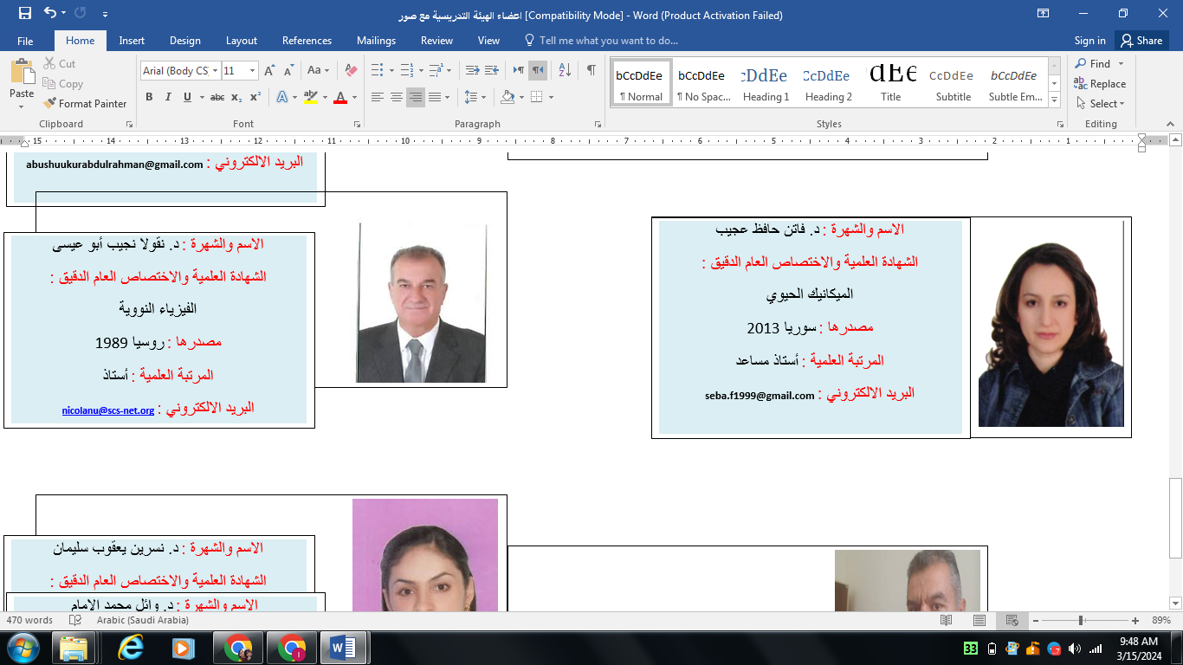

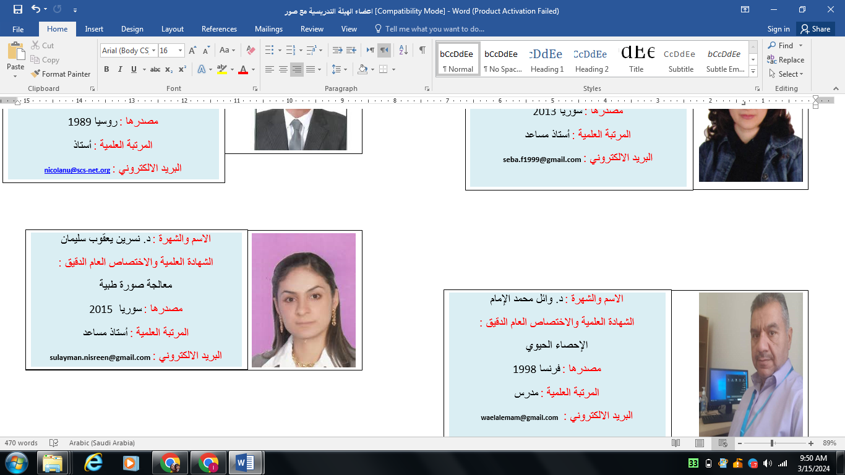

[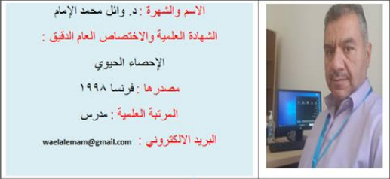](http://damascusuniversity.edu.sy/fmee/downloads/files/1670228553_%D8%AF.%D9%88%D8%A7%D8%A6%D9%84.pdf)

[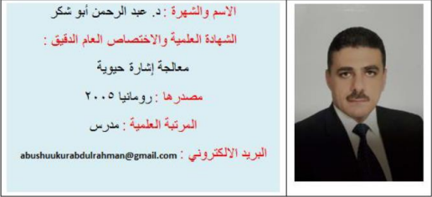](http://damascusuniversity.edu.sy/fmee/downloads/files/1670227095_Abdulrahman.pdf)